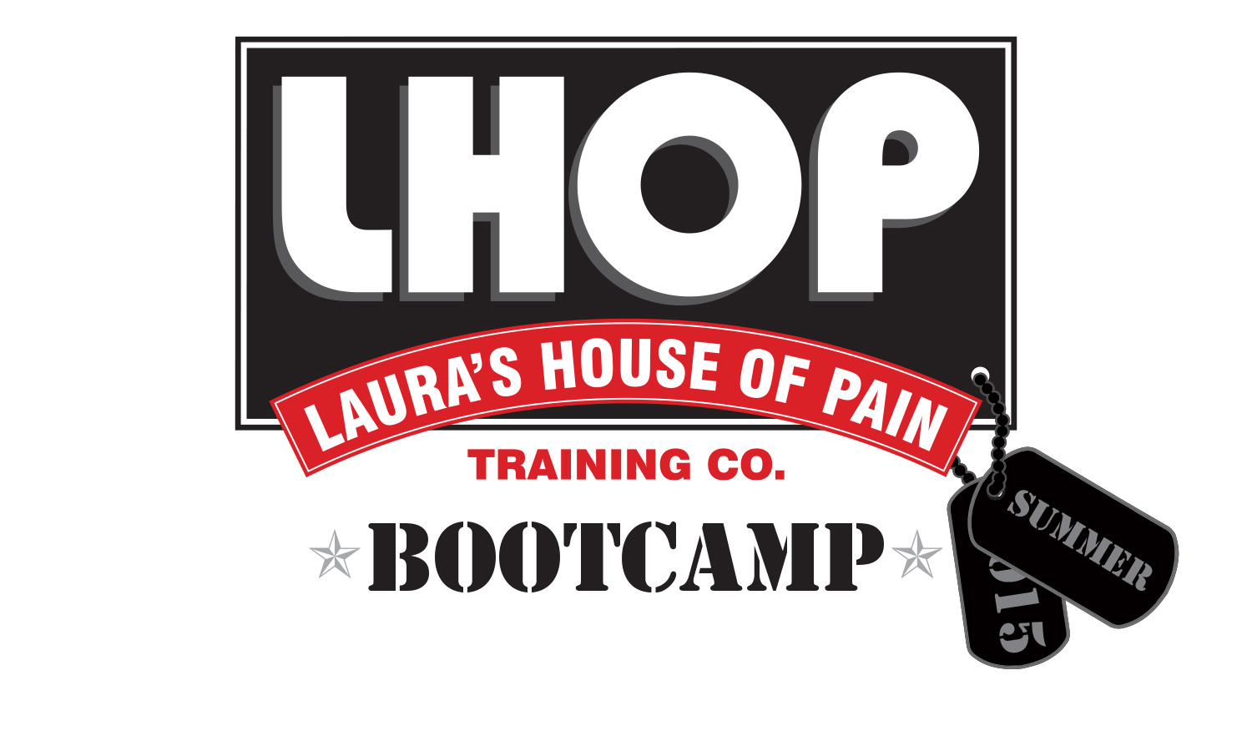

REGISTRATION FORM
Name:
Address:
City: |  |  |  |  |  | State: |  |  |  | Zip:
Phone: |  |  |  |  | Alt Phone:
Email:
Are you currently taking and/or prescribed medication? (Check Box) |  |  |  |  |  |  |  |  |  |  |  | Yes No
If yes, please list:
Class time (circle): 6:15am Shirt Size (circle): S M L XL Men’s V-Neck
Emergency Contact: |  |  |  |  |  |  |  | Relation:
Emergency Contact Number(s):
Please bring payment to first class. Checks made payable to LHOP

Assumption of Risk and Release
Client represents that he/she is in good health and has no disability, impairment, ailment or other medical or physical condition that may affect or restrict his/her participation with LHOP Training Company exercise program. Exercise involves risk; client agrees that LHOP Training Co. is not responsible for any injury including by way of example, heart attack, stroke, heat stress, sprains, broken bones, torn muscles and ligaments, paralysis or death. Client will be responsible for monitoring his/her own physical conditions during participation with LHOP Training Company exercise program. In the event the client experiences any adverse physical reactions or symptoms while exercising, the client will stop exercising. If the client is in doubt about his/her capability to participate in any physical exercise or training, the client will consult his/her physician.

By signing this Risk Release form, I confirm that I have read this form in its entirety. I also confirm that any questions I may have regarding the risk of injury involved in participation with LHOP Training Company, as well as my responsibilities in assuming that risk, have been answered to my satisfaction.
_______________________________________ _____________________________________ ____________
Print Client Name Client Signature Date

